NEWLAND PARISH COUNCIL

Clerk: J Barker
07539 605118
newlandpc1@gmail.com 13/08/2025

To all Members of Newland Parish Council

You are duly summoned to attend a Meeting of Newland Parish Council to be held at The Beauchamp Community on Tuesday 19th August 2025 at 7.00pm.

- To receive and consider apologies for absence.

- a) Declarations of Disclosable Pecuniary Interests and Other Disclosable Interests in items on the agenda
b) Notification of any changes to the Register of Interests
c) To consider any requests for Councillor Dispensation (s33 of the Localism Act 2011)

- Public forum – Members of the public may address the council on matters relating to the parish.

- To consider quotes (see appendix) and approve the purchase of two bus shelters to replace those recently destroyed in arson attacks.

- Date of next meeting. Tuesday 16th September 2025.

J Barker
Clerk, Newland Parish Council

Appendix - quotes for replacement bus shelters.

Option 1
Supply and installation for two new Wooden Bus Shelters (includes supply, installation, delivery and Vat.)
The “Village Rural Bus Shelter.” Delivery. £6100.00 £150.00 Total Net. £6250.00
We do ask for a confirmation of order 50% Deposit with final payment on completed installation. At present our lead time is between four to six weeks. A site visit will be arranged to meet your Council and to look at the logistics of the site. Discount of 5% if two shelters ordered.

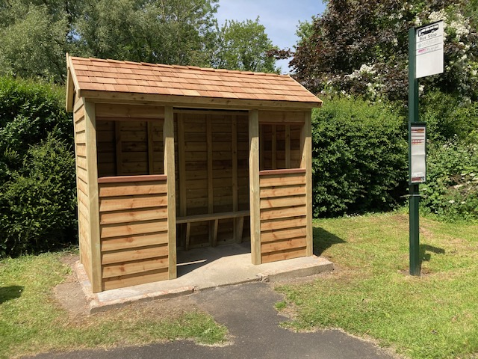
Option 2
Rettendon Wooden Bus Shelter
Purchase £7795 plus delivery (POA)
Installation by regular contractor estimated £150/shelter

This shelter can be adapted in many ways; all glazing and boarding is interchangeable, dimensions can be altered to fit the location.

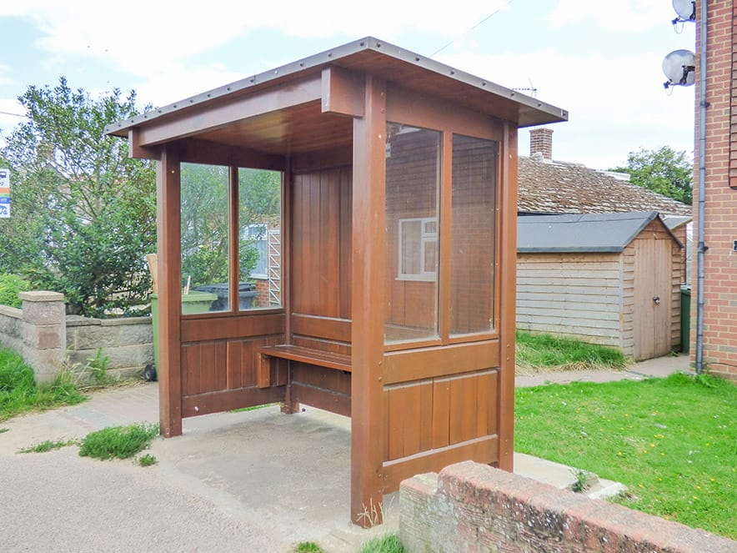

Made from sustainably sourced FSC® certified hardwood, have an expected lifespan in excess of 50 years, and come with a five year guarantee against being kicked in or burnt down. Delivered fully assembled by crane lorry.

